JBoss Six Products Demo

Presenters Guide Book

Version History 2
Welcome to the JBoss Middleware six products 3
Demo Scenario 3
Data Model 4
The Customer (Driver) 4
The Vehicle (Car) 4
The History (A Customer’s History) 5
The Policy (The Result of the Insurance Application Process ) 5
The Business Process 7
The Start Node 7
The Initialise Node 7
Human Task Get Driver 7
Calculate the risk for Driver (CalcDriverRisk) 8
Gateway 8
Human Task Get Car 8
Calculate the risk for Driver (CalcCarRisk) 8
Human Task Get History 8
Calculate the risk for Driver’s History (CalcHistoryRisk) 8
Calculate Overall Risk (CalcOverallRisk) 8
Calculate Price (CalcPrice) 9
Business Rules 10
Design of Portal 12
Get Driver Form 13
Get Car Form 14
14
Get History Form 15
Review Policy Form 16
16
Integration with Systems 17
System Management and Monitoring 18

Version History
Version | Author | Comments
1.0 | Derek Howlett | First Draft

Welcome to the JBoss Middleware six products

Welcome to the JBoss Middleware six products demonstration. If your new to JBoss middleware this suite of simple demos will allow you to get up and running with six of the most popular JBoss products very quickly.

Essentially we will demonstrate how easy it is to build an I.T platform for selling car insurance.

Although a simple representation of the actual insurance industry process it will cover all aspects of Enterprise architecture required to get to a fully functioning quote engine in place.

Demo Scenario

Data Model

A distinct and carefully designed data model can make your business and subsequent I.T systems very much easier to manage. Data modeling is often refereed to as the year two problem when systems are integrated together; there is a sudden realisation that the data on every system is formatted differently.

A well-designed and managed data model, which is implemented up front can save time, money and therefore reduce the costs of running your business.

For our six products demonstration we will design a simple data model, make links between the component parts and deploy into a central business repository.

PRODUCT 1 “JBoss Enterprise Data Services Platform”

Our first step is to start the data designer,

The Customer (Driver)

Create an entity to represent our customer, in the case of our insurance quote the customer is defined by a simple object called “Driver”.

Driver looks like the following: -

Driver
Description | Type
Name | String
Address | Object
Age | Integer
Social Security Number | String
Driving Licence Number | String
Credit Score | Integer

The Vehicle (Car)

Create an entity to represent the vehicle being insured, in the case of our insurance quote the vehicle is defined by a simple object called “Car”.

Car looks like the following:-

Description | Type
Make | String
Model | String
Year | Integer
Registration Number | String

The History (A Customer’s History)

Create an entity to represent the history of the Driver being insured, in the case of our insurance quote the history is defined by a simple object called “History”.

History looks like the following:-

Description | Type
Number of Accidents | Integer
Number of Tickets (traffic violations) | Integer

The Policy (The Result of the Insurance Application Process )

Create an entity to represent the insurance quote, this is defined by a simple object called “Policy”.

History looks like the following:-

Description | Type
Policy Number | Integer
Policy Date | Date
Named Driver | String
Address | Object Address
Car Registration Number | String
Total Risk | Integer
Driver Risk | Integer
Car Risk | Integer
History Risk | Integer
Price | Currency
Discount

The Business Process

Now that we have defined the Driver, the Car and the drivers history we move on to define the business process we must follow in order to arrive at a quote and a price.

PRODUCT 2 “JBoss Business Process Management”

To define the business process we will use JBoss Business Process Management.

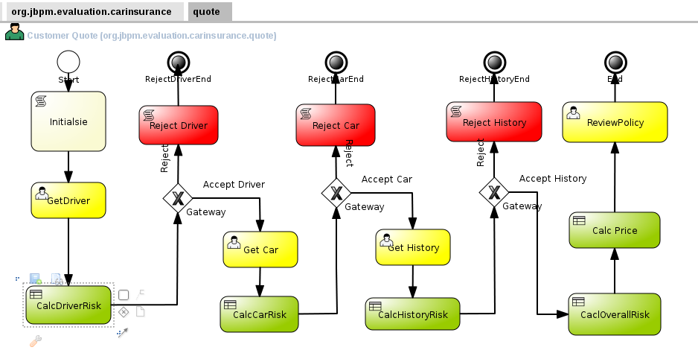

The Start Node
The start node indicated the beginning of the insurance quote. Note the domain name for the project org.jbpm.evaluation.carinsurance.quote

The Initialise Node
We use an initialise node to assign values to variable used in the process. In our case we set “validQuote” to true. If any stage in the process we decide the risk is too high, we simply set “validQuote” to false and reject the application.

Human Task Get Driver
The first human task in the insurance process is used to obtain details of the customer. Using a standard human task node we ask for the drivers name, age, social security number, driving licence number and credit score.

Calculate the risk for Driver (CalcDriverRisk)
This is the first decision point for the insurance process; we have collected the Drivers details. Calculate Driver Risk will take the details and decide on the risk associated with that driver and ad it to the Policy variable
:- Policy.DriverRisk. Driver Risk with then be used in the final pricing rule block.

Gateway
I use three decision gateways in the process to check the results of each of the rule blocks. If at any time the rule block decides the risk is too high I simply set the validQuote variable to false in the rule block and the gateway will route the process to the exit node associated with that decision.

Human Task Get Car
The second human task in the insurance process is used to obtain details of the vehicle. Using a standard human task node we ask for the make, model, year, registration mark,.

Calculate the risk for Driver (CalcCarRisk)
This is the second decision point for the insurance process; we have collected the car’s details. Calculate Car Risk will take the details and decide on the risk associated with that car and add it to the Policy variable
:- Policy.CarRisk. Car Risk with then be used in the final pricing rule block.

Human Task Get History
The third human task in the insurance process us used to obtain details of the drivers recent history,. I ask for number of accidents and the number of traffic violations or parking tickets etc.

Calculate the risk for Driver’s History (CalcHistoryRisk)
Again another rule block is used to calculate the risk associated with the driver’s history, The more accidents and the more traffic tickets, the higher the risk,
Calculate History Risk will take the details and decide on the risk associated with that drivers History and add it to the Policy variable
:- Policy.HistoryRisk. HistoryRisk with then be used in the final pricing rule block.

Calculate Overall Risk (CalcOverallRisk)

Once I have the Drivers details, Vehicle details and the History stored in DriverRisk, CarRisk and History Risk I use a decision table to calculate the overall risk. This is stored in a policy variable called Policy.OverallRisk.

Calculate Price (CalcPrice)

Calculate Price is the final rule block, which simply assigns a price based on the overall risk calculation done in the previous step.

Business Rules

PRODUCT 3 “JBoss Business Rules Management Platform”

Design of Portal

PRODUCT 4 “JBoss Enterprise Portal Platform”

Login Form

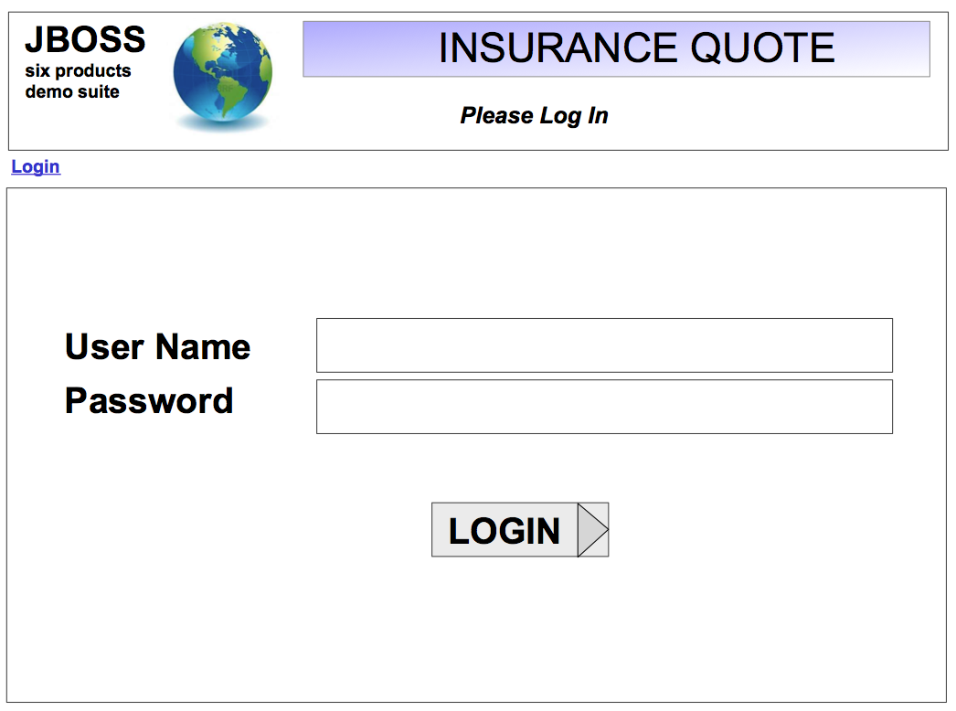

Get Driver Form

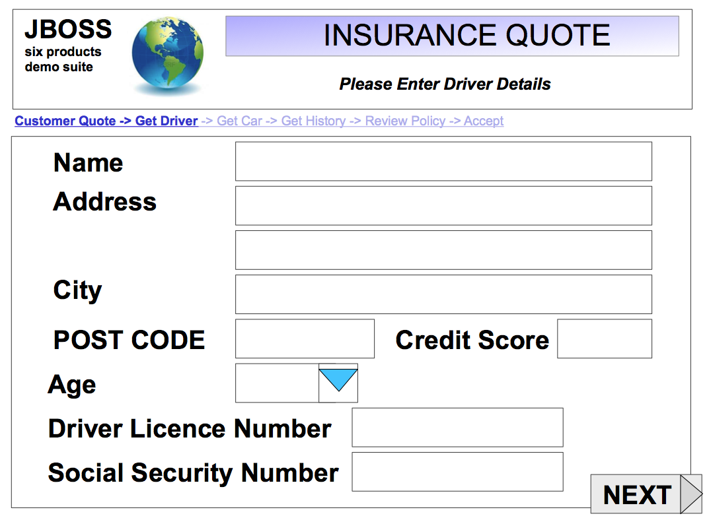

Get Car Form

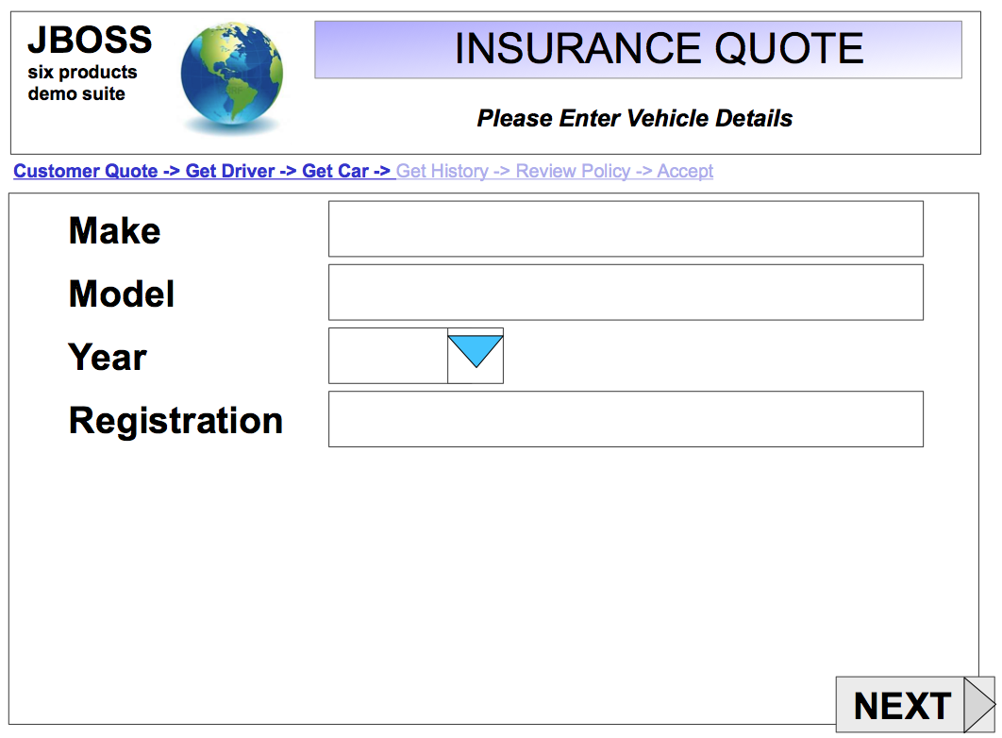

Get History Form

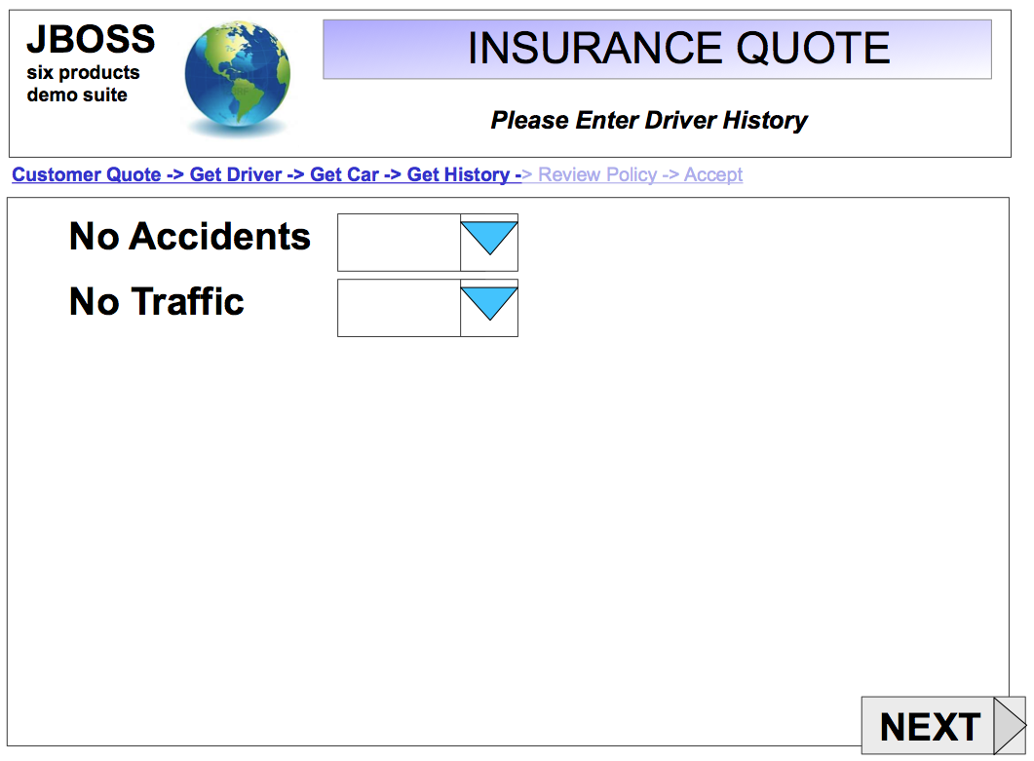

Review Policy Form

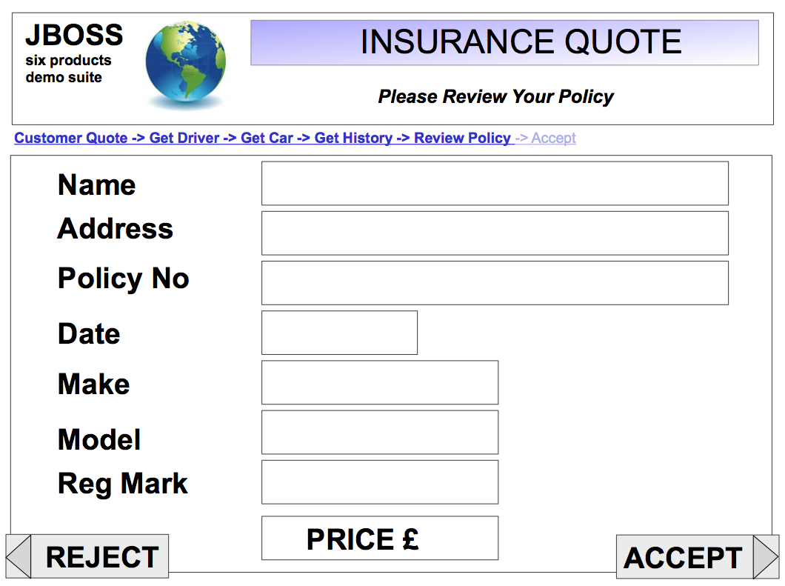

Integration with Systems

PRODUCT 5 “JBoss Service Orientated Architecture Platform”

System Management and Monitoring

PRODUCT 6 “JBoss Operations Network ”

